Output of Task3.

1. .Now I am accessing the application without the localhost as minikube will use his own network, so I have taken minikube ip and added entry in the **sudo vi /etc/hosts**  file , once we add in the hosts file then we will be able to access the application.
2. Below I have also mentioned how to access the application by using the localhost with port forwarding method.

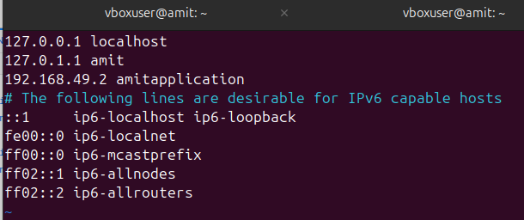

As I am using the Nodeport service to expose the application to outside world and for that reason I am using the 30622 port.(because the nodeport range is 30000 to 32767)

1.**Addition of item to database.**(POST API)

Command = [http://amitapplication:30622/add-item](http://localhost:35622/xyz)

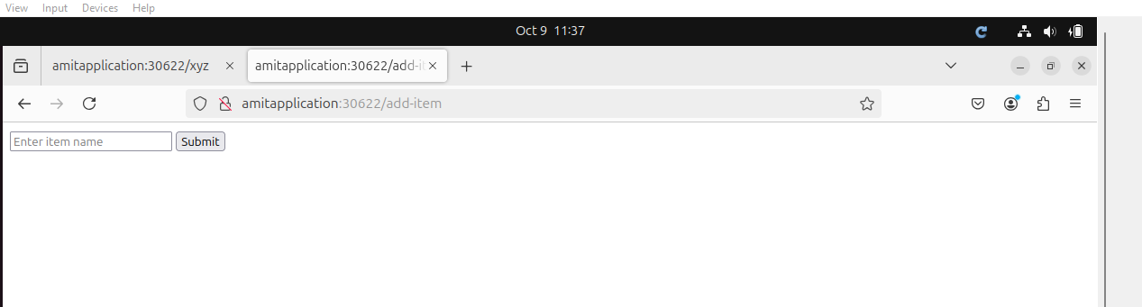

2.Enter the item and press enter to process that request.

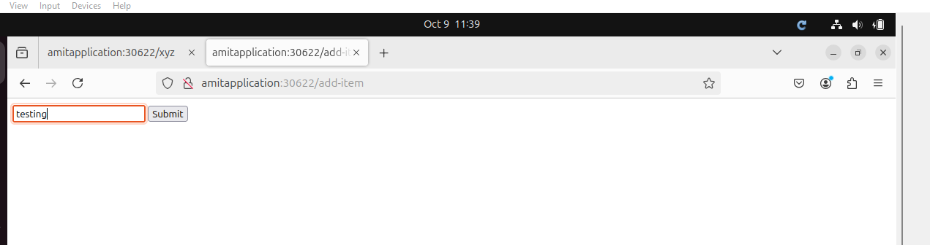

1. Once you press the enter , the item is automatically added into database.

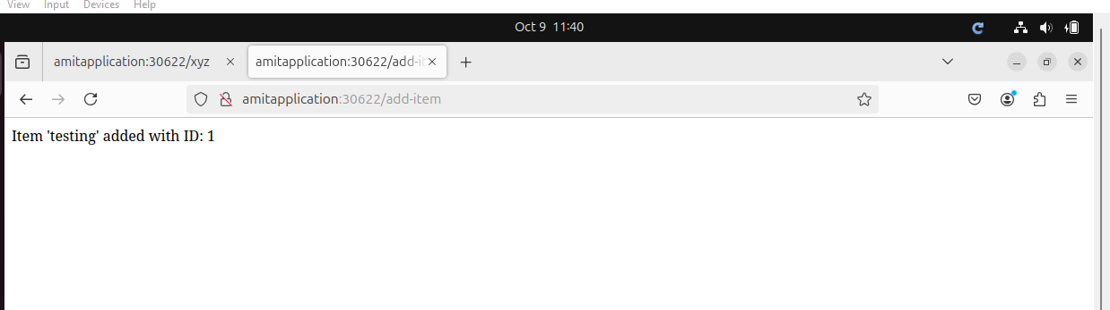

1. **Reading the data from the database.**(GET API).

Command = [http://amitapplication:30622/xyz](http://localhost:35622/xyz)/items

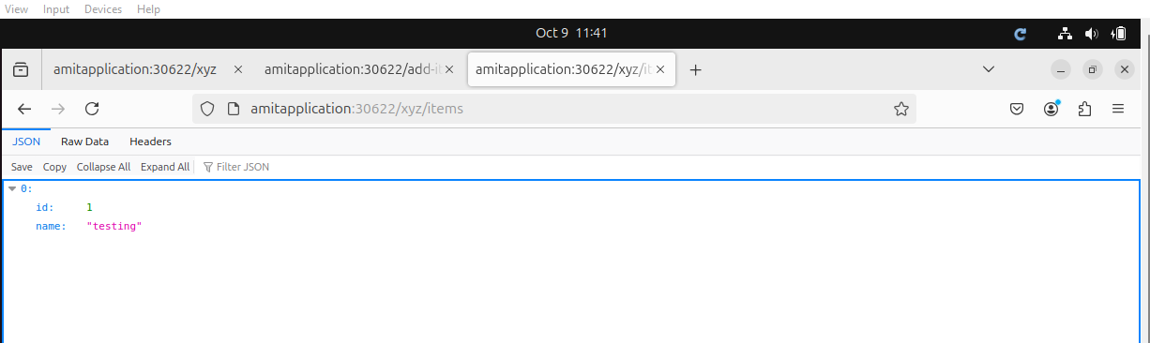

5.**Accessing the Application**

Command = [http://amitapplication:30622/xyz](http://localhost:35622/xyz)

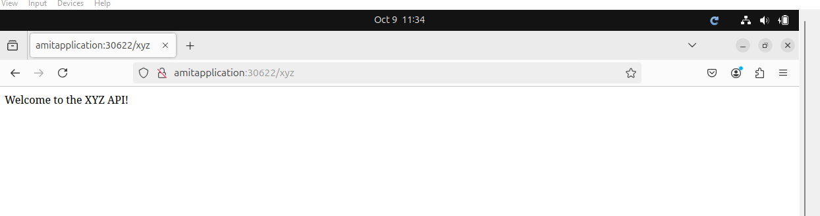

6**.verifying the database mysql.**

Login to mysql database (commad = kubectl exec -it pod-name -- bash)

Once it goes inside the pod enter this user command (mysql -u user -p)

After this it will ask the password - please enter the password which is set in the yml file.(password)

Once it get logged in , please use the mydatabase for querying (command = use mydatabase;)

Check the data in the database (command = select \* from item;)

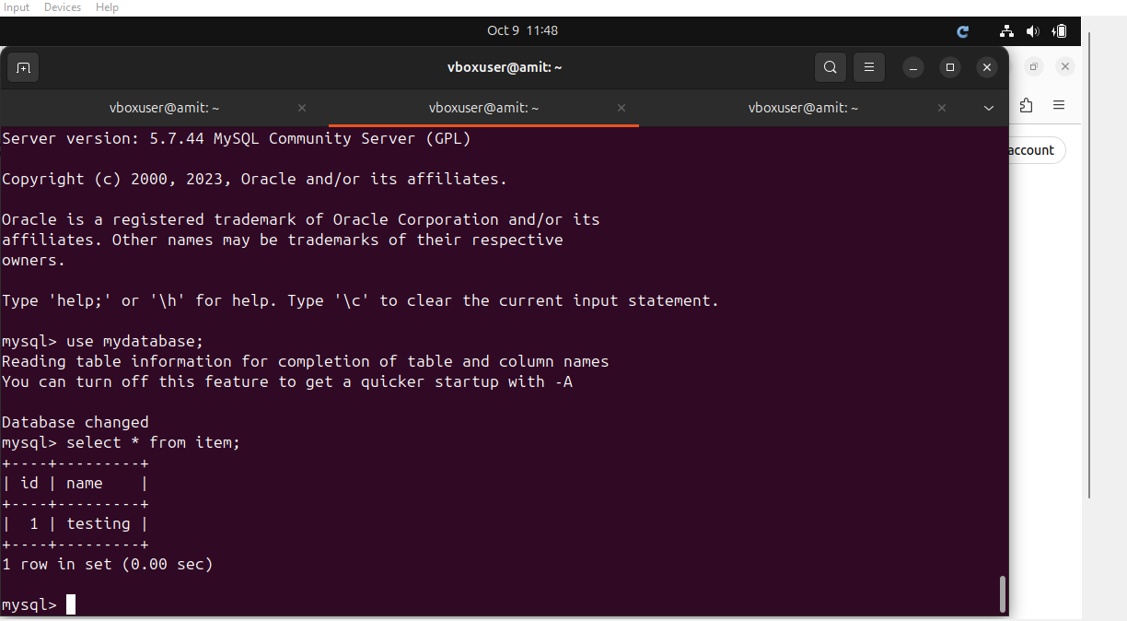

**TESTING WITH CURL COMMAND**

You can also test with curl command also.

Below are the curl command which are for POST and GET and for accessing the application.

1. POST API.

Command = curl -X POST [http://amitapplication:30622/xyz/add](http://localhost:35622/xyz/add" \t "https://mail.google.com/mail/u/1/" \l "inbox/_blank) -H "Content-Type: application/json" -d '{"name": "Item1"}'

2.GET API.

Command = curl -X GET [http://amitapplication:30622/xyz/items](http://localhost:35622/xyz/items" \t "https://mail.google.com/mail/u/1/" \l "inbox/_blank)

1. Accessing an application.

Command = curl -X GET [http://amitapplication:30622/xyz](http://localhost:35622/xyz" \t "https://mail.google.com/mail/u/1/" \l "inbox/_blank)

All the three output are there in single screenshot only.

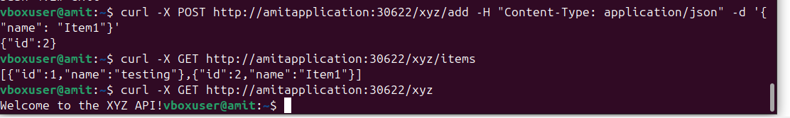

**ACCESSING AN APPLICATION WITH LOCALHOST BY PORT FORWARDING.**

**1.Forwording the port.**

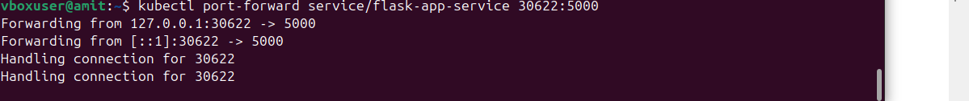

**Once we forward the port , we can access with localhost , please refer the below screenshots.**

1. **access an application.**

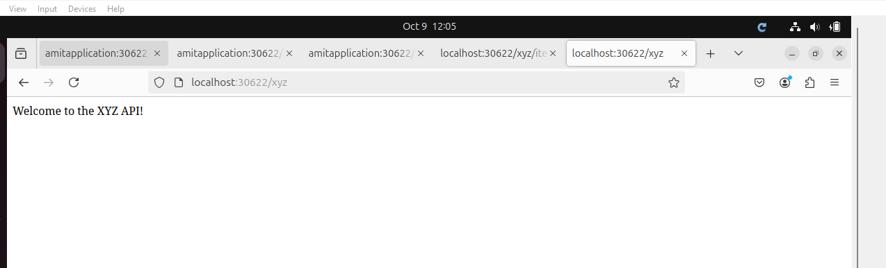

1. **Read operation.**

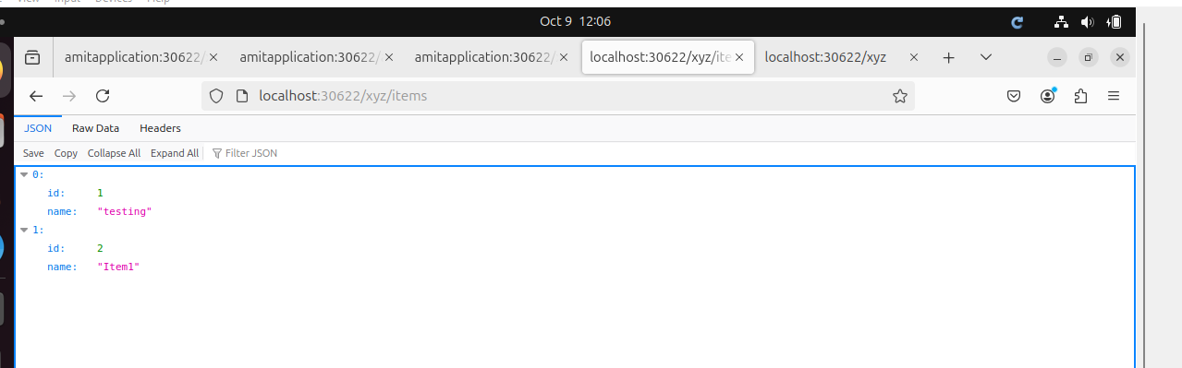

1. **Write Operation.**

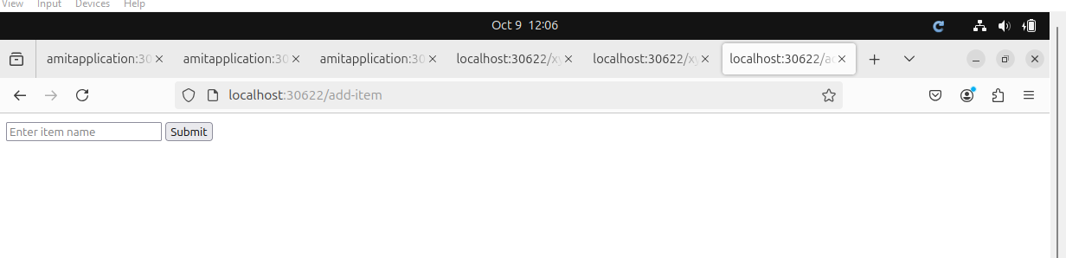

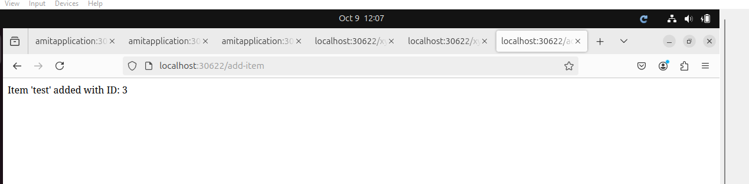

**WORKING WITH HPA.(Horizontal pod auto-scaling)**

**1.Before applying the load.**

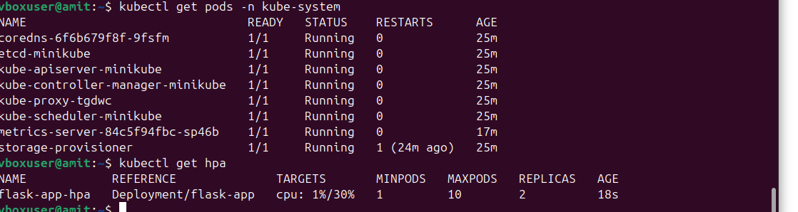

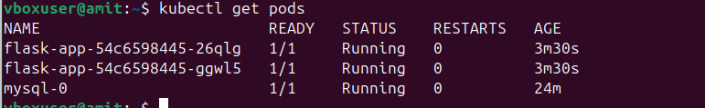

1. **After applying the load.**

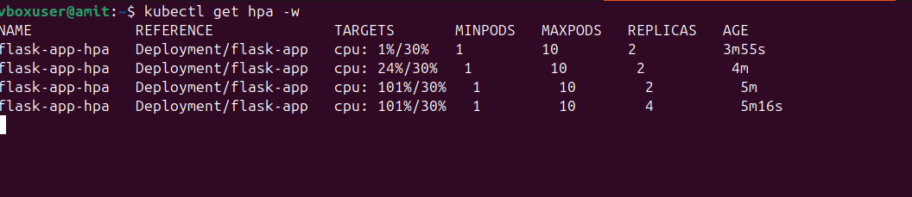

**After load the pods are getting created.**

